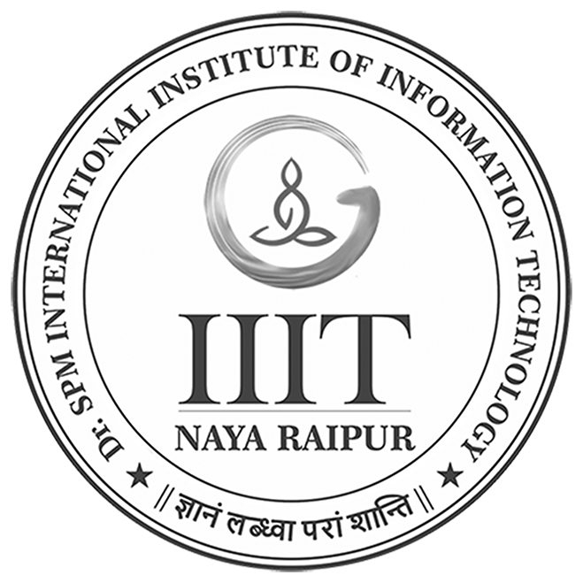 | Prajjwal Tawri  B.Tech – Computer Science Engineering  International Institute of Information Technology, Naya Raipur (IIIT-NR) |  | Phone: +91-8349082028  Prajjwal12tawri@gmail.com  https://www.linkedin.com/in/prajjwal-tawri-b7222116b/
Education
Degree/Certificate | Institute/Board | CGPA/Percentage | Year
B.Tech | IIIT Naya Raipur | 8.2 CGPA | 2018-2022
Senior Secondary | CBSE | 89.6 % | 2018
Secondary | ICSE | 88.6% | 2016
Experience
- Analyst – Deloitte Consulting June 2022 – present
    - Contributed to various Salesforce domains, including omniStudio(Vlocity), Sales Cloud, and Service Cloud.
    - Utilized skills in JavaScript, LWC, Aura, Apex triggers, and flows across different projects.
    - Recognized with a spot award for outstanding contributions to Sales Cloud Apex Triggers, Flow, and LWC Component project.
- Analyst(Intern) – Deloitte Consulting Jan 2022 – June 2022
    - Gained hands-on experience with Salesforce during the internship.
    - Worked on a project involving Salesforce Sales Cloud, engaging with triggers, Apex classes, LWC, and setups.
Technical Projects
- Fire Fighting Drone with Machine Learning:-Applied machine learning methods (Artificial neural network) to detect fire and predict the level of threat. Software used:- OpenCV , Mission planner, Open source drone using pixhawk and ROS.
- Automatic Soil irrigation System:-Designed a system to detect the moisture of the soil using soil moisture using sensor and provide needed water to soil using a code in Arduino.
- Solar Tracker:- A single axis solar tracker to follow sun’s movement from east to west to produce more solar energy using LDR sensor , Transistor and 555IC.
- Face recognition for criminal detection:- Face recognition is used in a GUI application to recognize registered offenders in pictures and videos. Facenet architecture is utilized for face recognition, while tkinter is used to create the GUI application.

Positions of Responsibility
- Atharv: Head of the Chess club (Society for sports).
- Event Head at Technovate 3.0,2020

Achievements
- 3 Spot Award (2022-2023) - Deloitte Consulting, 3 awards received for dedicated work on the projects.
- Hult Regionals: Secured runner up position in HULT regionals - 2020
- Chess-Participated in state level.

Technical Skills
- Languages: C++; C; Java; Python; JavaScript; Apex;
- Frameworks and Libraries: Visual Studio; Microsoft SQL Server; NodeJS; AngularJS; MongoDB
- General: Data Structures, Algorithm, Object Oriented Programming, Machine Learning, Deep Learning, Salesforce Sales cloud, Salesforce Service Cloud.

Additional Skills
- Active in e-Sports
- Acoustic Guitar player.
- Can solve a Rubik’s cube under a minute.
- A good team player, great problem solving and time management skills and honest.

Certifications
- Salesforce Certified Administrator (SCA) - Salesforce(Credential Id: 3434910)
- Salesforce Certified Platform Developer I - Salesforce(Credential Id: 2739241)

